LAB EQUIPMENT BOOKING PORTAL
@CREATIVITY THINK (9483175986/7019689991)

ABSTRACT:
The Lab Equipment Booking Portal is a web-based application that enables students and faculty to reserve lab equipment through a structured slot-based system. The platform allows users to browse equipment, view availability calendars, and make bookings efficiently. Administrators can manage equipment, define slot rules, approve or reject booking requests, and analyze equipment usage through an interactive dashboard. The system is developed using Django REST Framework for backend APIs and React for a dynamic, responsive frontend. This platform is ideal for colleges, computer labs, and research facilities that require organized access to lab resources..

INTRODUCTION OF THE PROJECT:
Academic and research institutions often face challenges in managing lab equipment usage due to manual booking systems, unstructured schedules, and miscommunication. Students frequently encounter issues such as double-booking, unclear availability, and a lack of real-time updates. The Lab Equipment Booking Portal resolves these problems by offering a digital solution where users can view live availability, select time slots, and book equipment with transparency. Administrators receive complete control over equipment, slot rules, booking approvals, and analytics, ensuring efficient resource management and optimal equipment utilization..

PROJECT OBJECTIVES:

• Provide a secure platform for booking lab equipment based on availability
• Display equipment list with real-time slot calendars
• Allow students to book, cancel, or reschedule slots as per defined rules
• Enable administrators to approve or reject booking requests
• Maintain booking history and usage logs
• Generate usage analytics such as busiest hours and most-used equipment
• Implement responsive UI using React and react-calendar
• Offer role-based access for users and administrators

PROBLEM OF THE STATEMENT:
Most educational institutions rely on manual registers or informal communication for lab equipment usage. This leads to double bookings, mismanagement, delays, and inefficient resource utilization. Students often lack visibility into real-time availability, while administrators struggle with maintaining logs and handling conflicts. The Lab Equipment Booking Portal addresses these issues by delivering an automated, transparent, and rule-based digital booking platform..

MOTIVATION OF THE PROJECT:
• To eliminate manual booking errors and reduce administrative workload
• To provide equal access to equipment for all students and faculty
• To implement a structured, rule-based reservation mechanism
• To enable real-time visibility of equipment availability
• To provide data analytics for improving lab resource planning
• To modernize educational labs with smart scheduling tools

BLOCK DAIGRAM OF PROJECT:

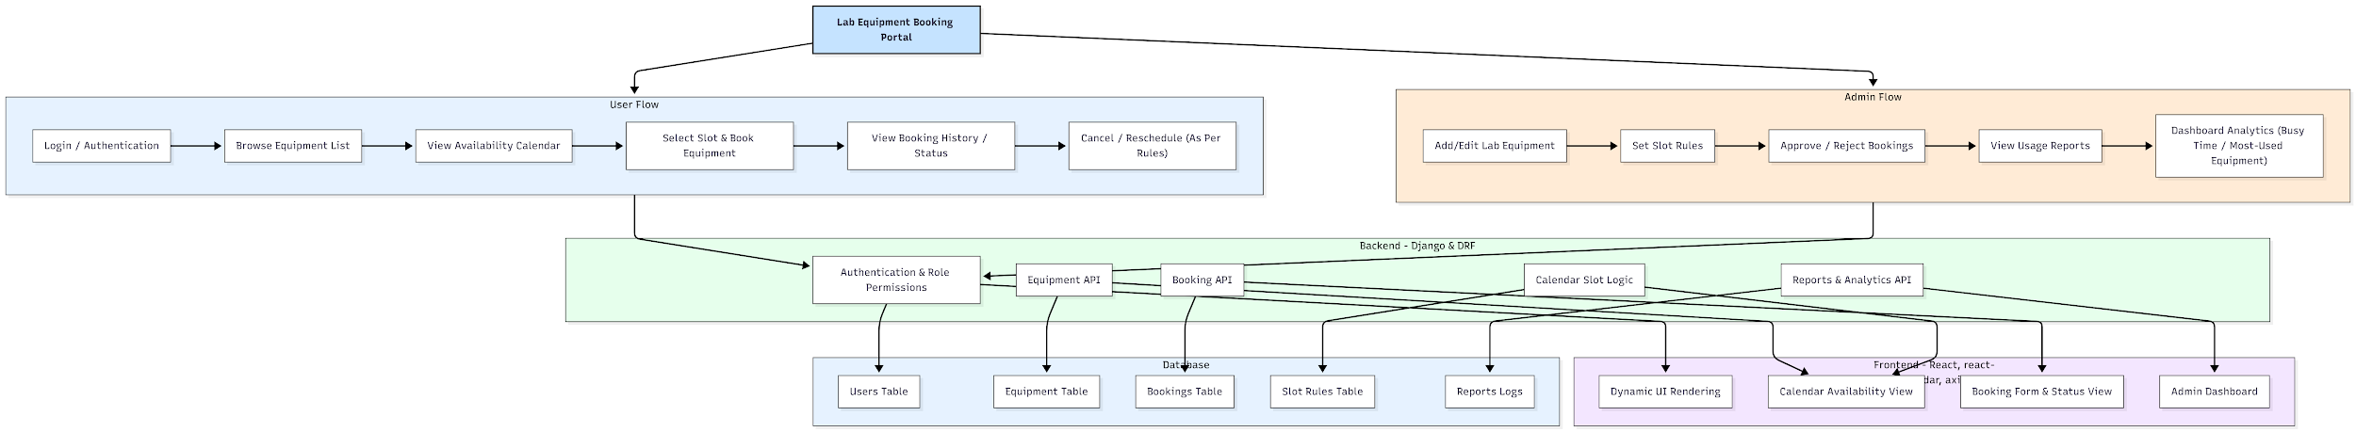

WORKING OF THE PROJECT:
Students begin by logging into the portal using their credentials. They can browse the list of available equipment and check its availability using an interactive calendar component. Based on slot rules defined by the admin, users can select a suitable time slot and submit a booking request. The admin reviews these bookings and either approves or rejects them. Once approved, the booking is locked into the system and visible in the user’s booking history. Users can also cancel or reschedule bookings subject to defined rules. Administrators gain additional insights through the dashboard showing usage trends, busiest time intervals, and frequently booked equipment, enabling informed lab resource planning..

SOFTWARE REQUIREMENT:
- Backend:
  - Python 3.x
  - Django
  - Django REST Framework
  - SQLite/PostgreSQL
- Frontend:
  - Node.js and npm
  - React.js
  - Axios
- Development Tools:
  - Visual Studio Code
  - Postman (for testing APIs)
  - Git/GitHub (for version control)
- Server/Deployment (Optional):
  - Gunicorn, Nginx, or Heroku/AWS for hosting

ADVANTAGES OF THE PROJECT:

• Eliminates manual booking errors and double-booking issues
• Provides real-time availability and slot-based scheduling
• Ensures transparency through booking history and status tracking
• Offers admin control for equipment management and rules configuration
• Generates useful analytics for lab resource optimization
• Simple, user-friendly UI for both students and administrators
• Improves discipline and organization in lab usage

APPLICATIONS OF THE PROJECT:
• College engineering labs
• Computer laboratories
• Research and project labs
• Electronics/IoT labs with limited equipment
• Shared resource management systems

REFERENCES:

- Django REST Framework Documentation — Django Software Foundation. Django Documentation. Available: https://docs.djangoproject.com/
- Django REST Framework. DRF Documentation. Available: https://www.django-rest-framework.org/
- React. React Official Documentation. Available: https://reactjs.org/docs/getting-started.html
- Redux. Redux Documentation. Available: https://redux.js.org/introduction/getting-started
- PostgreSQL Global Development Group. PostgreSQL Documentation. Available: https://www.postgresql.org/docs/
- MySQL. MySQL Reference Manual. Available: https://dev.mysql.com/doc/
- Git. Git Documentation. Available: https://git-scm.com/doc
- Node.js. Node.js Documentation. Available: https://nodejs.org/en/docs/
- Axios. Axios Documentation. Available: https://axios-http.com/docs/intro
- Socket.io Documentation – https://socket.io/docs/

